Name: kirolles emil William
Group: SWE1
Task 1:
Item | Your Finding / Terminal Output
Current branch | main
Number of visible branches | 3 (main, feature-search, feature-stock-validation)
Names of feature branches | feature-search, feature-stock-validation
Latest commit message on main | [Fill in latest commit message from your git log output, e.g. 'Initial baseline commit']

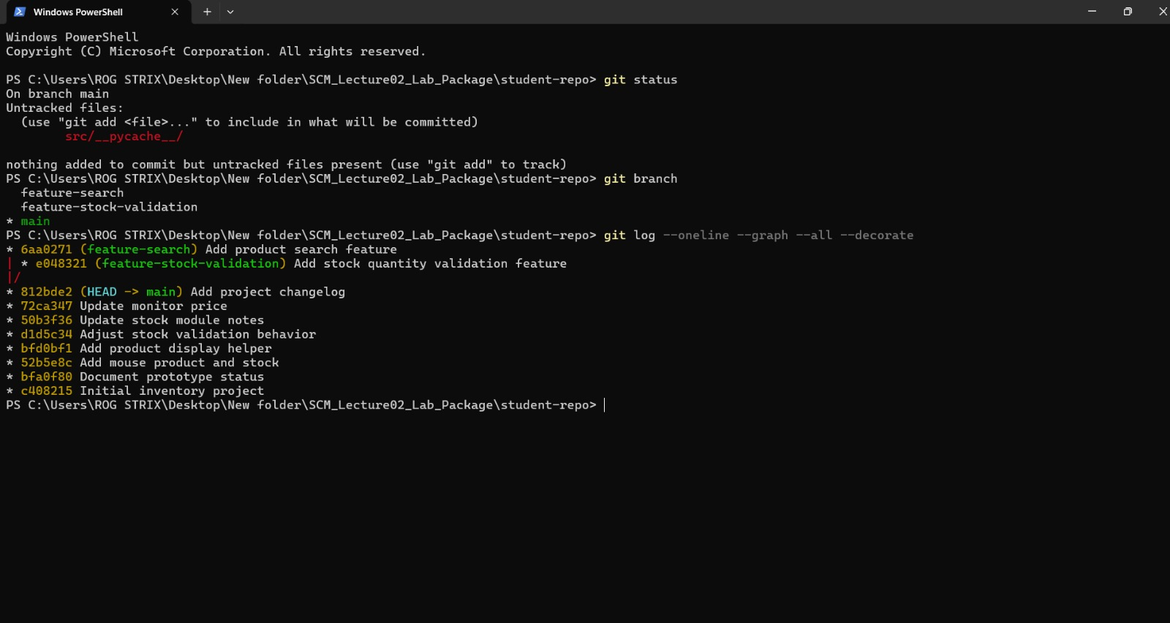

1. What is the main difference between a centralized VCS and a distributed VCS?
A CVCS stores the full version history on a single central server, whereas a DVCS gives every developer a complete local copy of the entire repository and its history.
2. Why is a distributed VCS less dependent on one central repository for local work?
Because the full repository history is stored locally, developers can commit, branch, diff, and view logs completely offline without needing a network connection
3. What is the purpose of creating a feature branch?
It isolates new features or bug fixes so developers can work concurrently without breaking the stable main codebase.
Task 2:
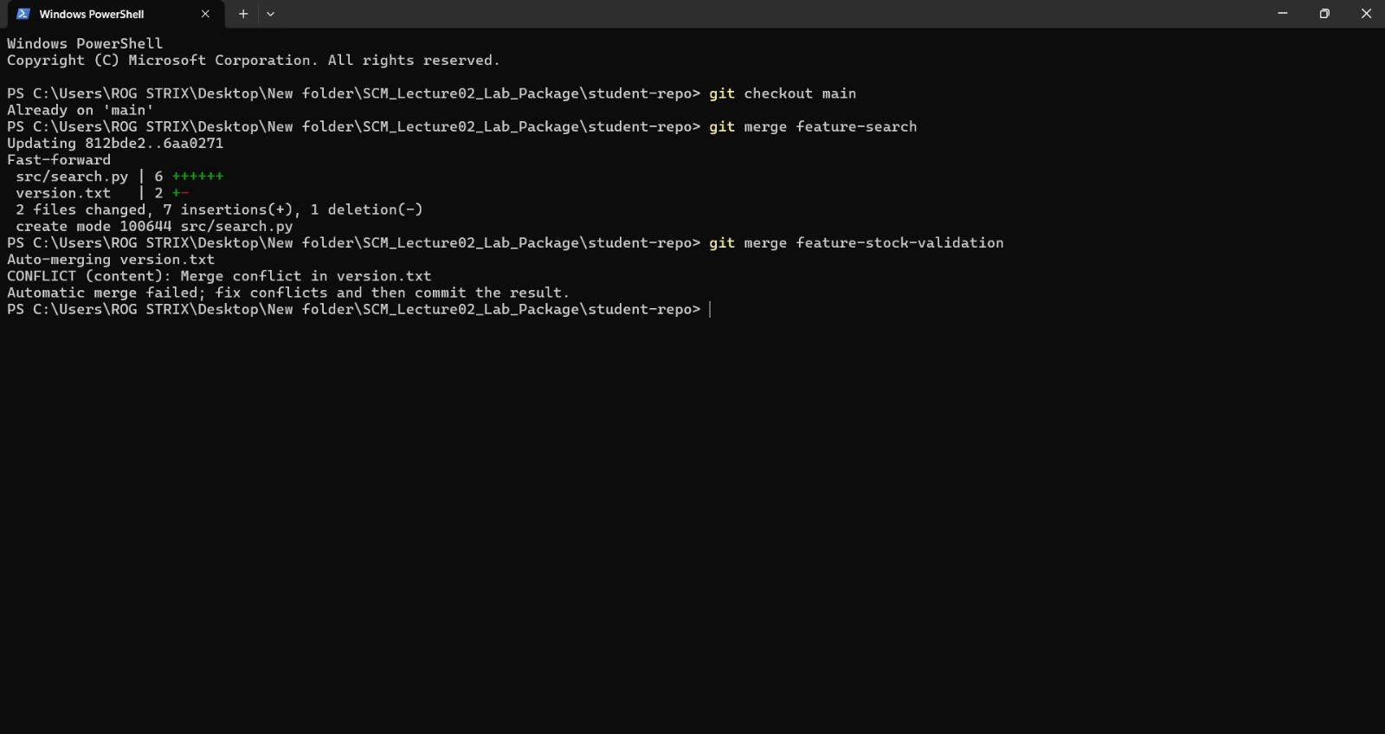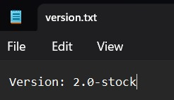
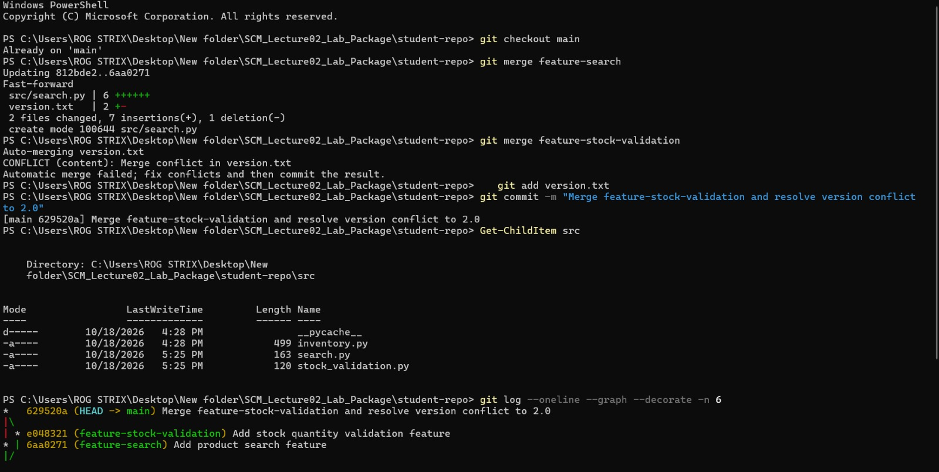

Why could Git not automatically choose between the two version numbers?
Both branches diverged from the same commit and modified the exact same line in version.txt. Git cannot determine which change should take precedence and requires manual resolution.

Task 3:
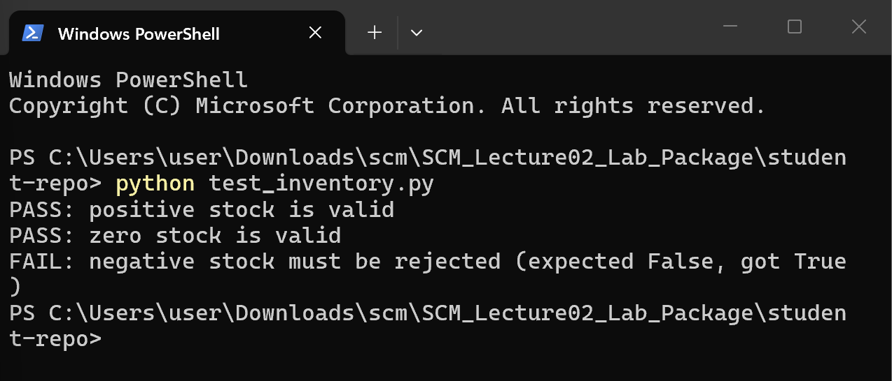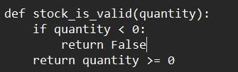
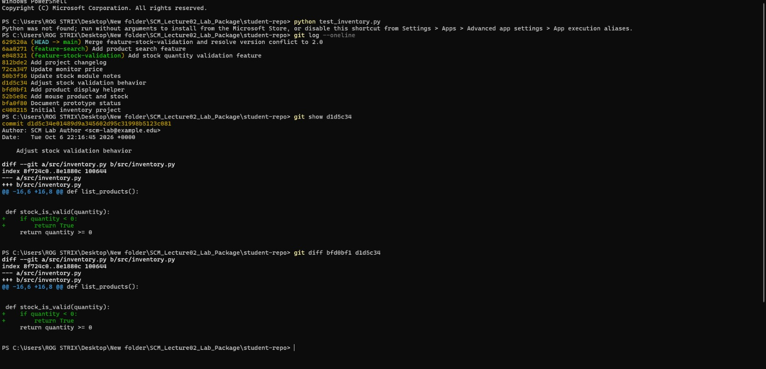

Investigation Item | Your Answer / Findings
Failing file / function | [e.g., src/stock_validation.py -> validate_stock_quantity()]
Commit hash that introduced defect | [Insert 7-char short hash found via git log / git show]
Commit message | [Insert exact commit message from that commit]
Incorrect behavior | [e.g., Allowed negative stock counts / used '>' instead of '>=']
Correct behavior | [e.g., Raise ValueError / ValidationError when quantity is < 0]
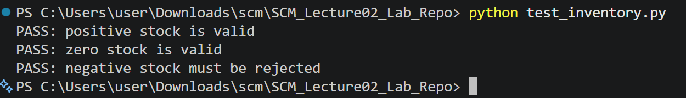

Task 4:
Algorithm | Easy to read? | Main Observation | Ranking (1-4)
Myers | Moderate | Default greedy algorithm; finds the shortest edit script but can split semantic blocks or matching brackets awkwardly across hunk boundaries. | 3
Minimal | Moderate | Spends additional computation to find strictly minimal line differences; output is often virtually identical to Myers for small sample files. | 4
Patience | Yes | Matches unique common lines first (like function signatures); avoids matching isolated brackets, producing clean, logically grouped hunks. | 1
Histogram | Yes | An optimized, high-performance variant of patience; handles repetitive and low-occurrence lines cleanly, keeping functions readable. | 2
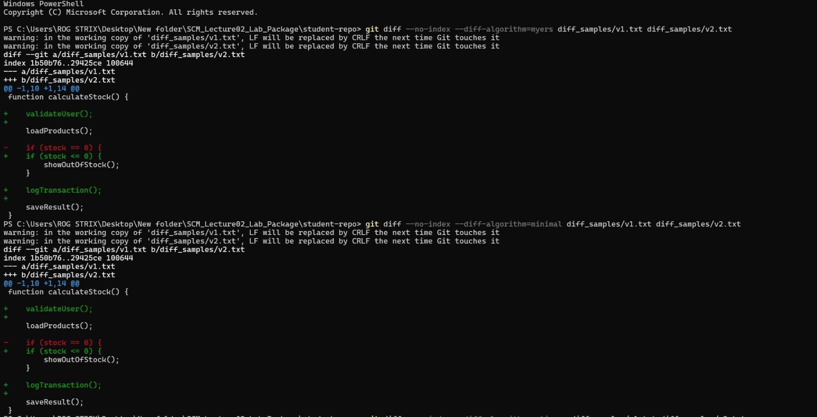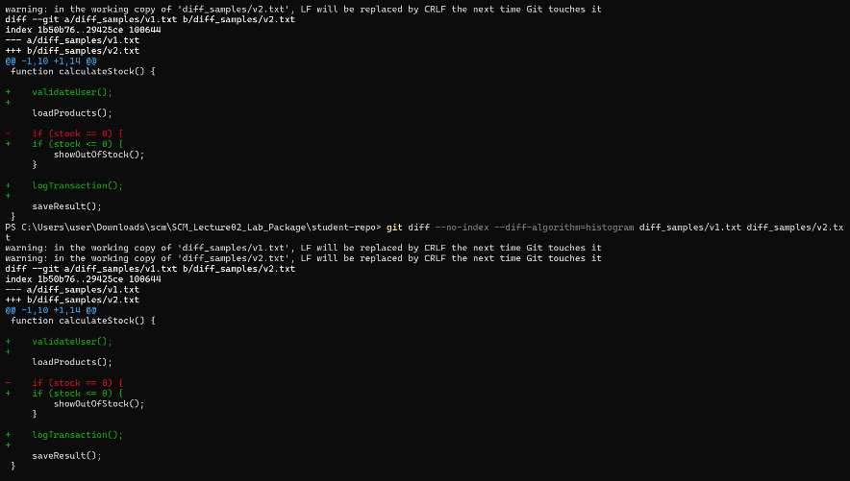

Which diff output was easiest for you to understand, and why?
Patience was the easiest because it aligns unique anchor lines (like function definitions) rather than matching random closing braces, keeping logical code blocks intact and readable.

Task 5: Distributed Collaboration: Commit, Push, and Pull (15 Marks)

Stage | Stored in A locally? | On remote? | Visible in B?
After edit | Working Tree only (untracked / modified) | No | No
After commit | Yes (Committed in local .git repo) | No | No
After push | Yes (Local repo updated) | Yes (Reflected in remote.git) | No (Not yet pulled)
After pull in B | Yes | Yes | Yes (Synchronized to B's working tree)

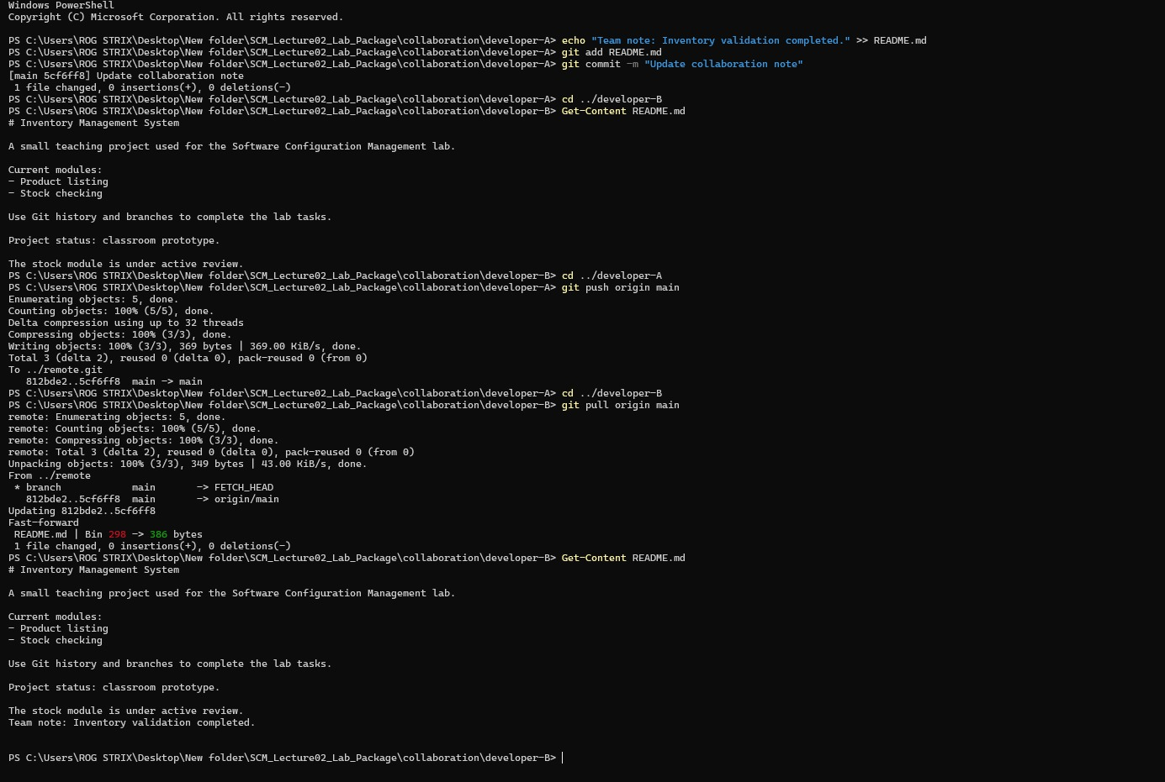

Question: Why does git commit alone not make Developer A's change visible to Developer B?
git commit only saves changes to Developer A's local repository. Developer A must git push to the shared remote, and Developer B must git pull to fetch and merge them.

Task 6:
1.Record the short hash of your latest commit. After making a new commit, does the new commit have the same hash or a different one?
Latest short hash: 5cf6ff8 (or 629520a). A new commit always generates a different hash because the hash is calculated from the file contents, parent hash, author, timestamp, and message—any change produces a completely new hash.

2. The lecture describes SHA-1 as producing 160 bits (20 bytes), usually displayed as 40 hexadecimal characters. Explain why 160 bits correspond to 40 hexadecimal digits.
Each hexadecimal digit represents 4 bits ($2^{4}=16$ values). Dividing 160 bits by 4 bits per digit equals 40 hex characters ($160/4=40$).

3. What is the purpose of hashing in a Git repository?
It uniquely identifies every object (files, trees, commits) and ensures data integrity; any tampering or corruption immediately alters the hash.

4. Which SSH key may be shared with a remote service: the public key or the private key?
The public key is the only key that may be safely shared with and uploaded to remote hosting services.

5. Why must the private SSH key be kept secret?
It proves your identity. Anyone with your private key can impersonate you and gain unauthorized access to your repositories.
Task 7: Final Report Reflection
Version control systems form the core of Software Configuration Management (SCM) by maintaining code stability, history, and integrity across teams. Git’s branching model isolates new features and bug fixes from the stable main branch, enabling parallel development without risking production code. When branches modify the same lines, Git halts and requires manual conflict resolution, preventing accidental overwrites. Because Git is distributed, every developer has a full local repository. This allows offline commits, diff comparisons, and rapid debugging using git log and git show before sharing updates with teammates via git push and git pull. Under the hood, cryptographic SHA-1 hashing gives every commit a unique fingerprint, making the repository history tamper-evident and guaranteeing data integrity. Coupled with asymmetric SSH keys for secure remote authentication, Git provides a dependable, auditable workflow essential for collaborative software engineering.

